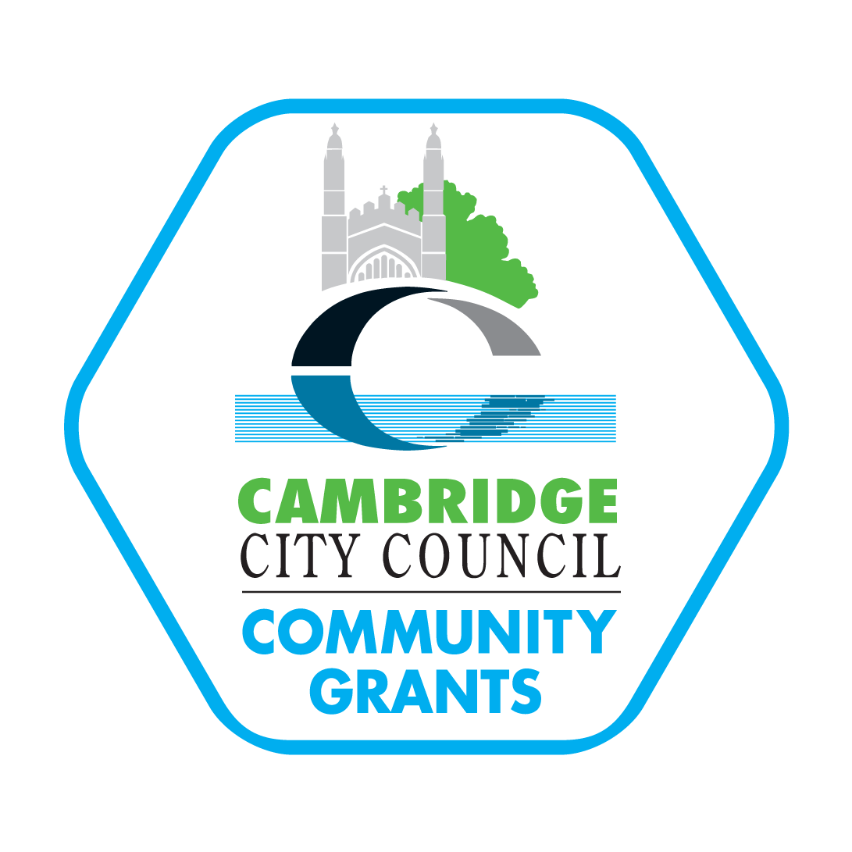
Cambridge City Council - Community Grants

Area Committee 2022-23
Monitoring Report

Friends of Midsummer Common

Important information: please read this carefully to ensure you plan the collection of monitoring information required to be able to complete this report in full and return it by the deadline.

- This grant comes from public funds and must only be used for the purpose allocated as stated in your Grant Agreement (or an alternative purpose approved in writing by the Grants Manager)
- Adequate monitoring must be provided to evidence how the grant has been spent and what difference it has made to City residents with the highest needs to reduce social or economic inequality
- Any award not spent or evidenced for the purpose allocated will have to be repaid in full
- You must collect the information to be able to complete this form in full
- You must have appropriate invoices and receipts to evidence all income and expenditure and we may ask to see these
- This monitoring report must be returned one month after the completion of your activity/service and by 30th April 2023 at the very latest to: grants@cambridge.gov.uk
- Outstanding and inadequate monitoring will affect future awards

1. Award and purpose

£900 for Community volunteering sessions, events and activities raising awareness of the orchard and increasing biodiversity of the Common.

2. Project/activity

2.1 You undertook to provide the above project/activity. Please give full details of exactly what was provided with this funding. Please report separately on each different activity that is funded by this grant.

Community volunteering sessions
Our volunteering sessions run weekly on Sunday mornings from 10am till approximately midday. We have had about 45 sessions in the 2022/23 year. As well as ongoing maintenance of the orchard – pruning trees and mowing – we have continued with a programme of improvement and renovation projects. These include:
- Improving the soil structure of the Newmarket Road entrance to the orchard by mulching with soil improver and woodchip. Adding new planting to provide cover for wildlife and aesthetic value.
- New plantings, replacing plants that died in the drought, also weeding around the trees in our cherry tree avenue to give them the best opportunity to grow
- Sowing wildflower seeds and bulbs along our cherry tree avenue, and mowing said area with scythes once a year.
- Erecting new structure of poles to support the growing hops
- Construction of a compost bin
- planting new hedging to compensate for the removal of mature beeches along the border of the orchard.

We have volunteers from all walks of life and several Duke of Edinburgh Award candidates. We try to include an educational component to volunteering sessions, including discussion of grafting and propagation, soil assessment and improvement, and traditional orchard management.

Events/activities raising awareness of the orchard
We held our second Wassail at the orchard – a traditional event to celebrate our trees. It was well attended and enjoyed by all. We also held an apple day, where we pressed some apples and enjoyed the juice. We have a mowing day in late summer where people can learn about traditional meadow management and see scything taking place. We provide refreshments such as coffee and cake at these events. These days have served to involve the wider community and engage future volunteers.

From our google analytics below, you can see that people are finding our orchard via searches for the common but also for volunteering activities.

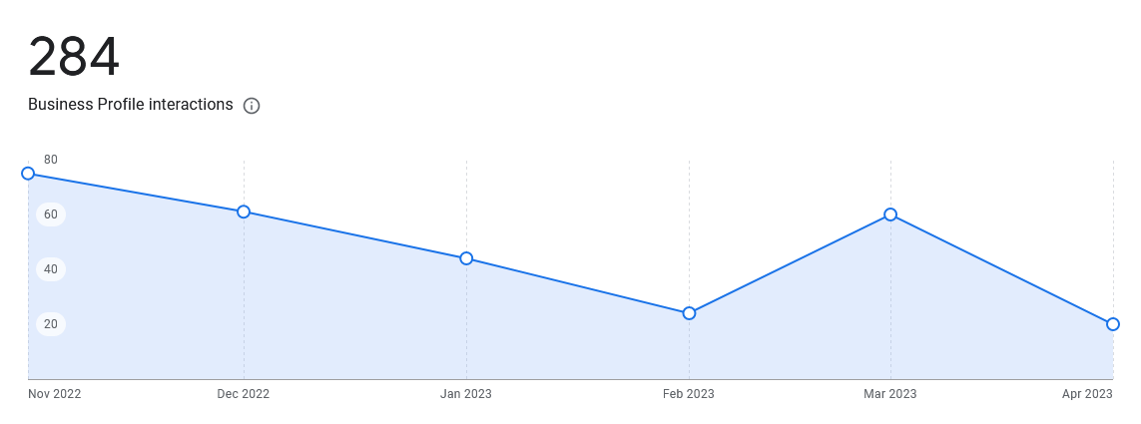
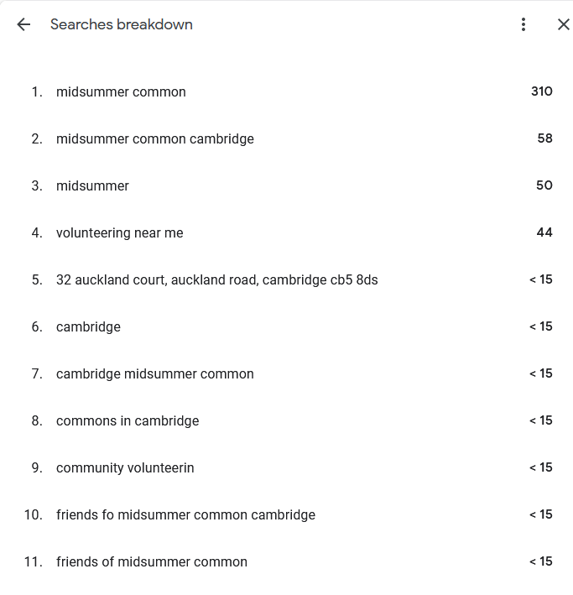

Please ensure you state where the activity was held, when, how many sessions over how many weeks etc. e.g meetings x 42 held at xxx community centre 10-11 am with coffee & biscuits, with a monthly speaker on topics such as xx.
Activity start date: | Weekly volunteering sessions in the Orchard (about 45 in the year) starting at 10 a.m. and ending about midday. | Activity end date:

2.2 If there were any differences in the activity which you received an award for, from what you actually did, please provide details:

3. Beneficiaries

3.1 Who benefited from the activity? (e.g. older people, children, people with disabilities etc.)? Who did you target?

Our volunteers come from all walks of life. Many of them are elderly. Some have disabilities. Many of us do not have gardens/outdoor space of our own. We have several Duke of Edinburgh candidates. We also have several people who have recently arrived in the UK from other parts of the world and have found the orchard as a good way to connect to their new home.

We performed a survey at our Wassail event in January to establish what needs people had. This was optional and not all attendees filled out the survey. Of 15 respondents (about 1/3 of attendees at the event)
- - 8 were regular volunteers
- - 2 were under 17
- - 4 were over 65
- - 4 live alone
- - 4 had no outdoor space at home (gardens, balconies, shared gardens etc)
- - 3 of those with gardens stated that their gardens were very small
- - 3 were retired
- - 2 were students
- - 2 were not in full or part time employment or study
- - 4 people got their only form of exercise in the orchard
- - 6 exercised in the orchard as well as elsewhere
- - 4 considered themselves to have a disability
- - 5 were vulnerable to covid and so have had to shield in the past two years.

3.2 How many people directly benefited in total? A direct beneficiary is someone actively participating in the activity and not observing the activity (such as audiences at performances etc.). There is a separate question to tell us about indirect beneficiaries.
What are the ages of the beneficiaries?
 | Total number of beneficiaries for each age group? | How many of these live in the City?
Under 5’s | Estimate several hundred | Majority
5-17 | Estimate several hundred | Majority
18-59 | Estimate several hundred | Majority
60 and over | Estimate several hundred | Majority
Total | Very hard to estimate the numbers who pass through Orchard. Perhaps 15,000, although maybe fewer this year because of Covid. Many more live in surrounding streets and use the Common, for whom we aim to act as advocates. | Majority

3.3 Where do those people live? Put how many against each ward in the table below. If you are not sure, please make a best guess.

Area | Wards
North | Arbury | West Chesterton |  |  | East Chesterton |  | Kings Hedges
East | Petersfield | Romsey |  |  | Abbey |  | Coleridge
South | Trumpington |  |  | Queen Edith’s |  | Cherry Hinton
West Central | Market |  |  | Castle |  | Newnham
Other - not Cambridge City residents |  |  | Thousands use the Common from everywhere, and we estimate at least 15,000 (more than 50 a day) visit  the Orchard through the course of a year.
3.4 Please provide details of any indirect beneficiaries i.e., people who did not actively participate in the activity but may have observed or benefited in another way, such as audiences and communities.

Thousands use the Common from everywhere, and we estimate at least 15,000 (more than 50 a day) visit
the Orchard through the course of a year.

4. Benefits/outcomes

4.1 How did your activity reduce social and/or economic inequality for city residents? How do you know that this was achieved?

Parks and green spaces help to mitigate socio-economic-status related health inequalities, particularly when those green spaces are well maintained and high quality.

We had twenty regular attendees to volunteer sessions, plus other occasional participants. and our wider membership is much larger however.

The Midsummer Common Community Orchard has always been volunteer-run by Friends of Midsummer Common since its establishment in 2009. It is a beautiful space and we get many verbal comments from those enjoying the orchard or simply walking through it on their morning commute.

It’s important to point out that the orchard does not only benefit the affluent of Market Ward. There are many unhoused people who frequent the orchard as a quiet place to sit where they will be treated with dignity. We liaise with authorities when appropriate or when someone needs help.

The police are particularly keen that we keep the orchard well maintained and encourage local use, since this can reduce anti-social behaviour. The increased use of the orchard by all parts of the community, including families, retired people and students over the past year seems to have borne this out, making the orchard a safe and welcoming place for all members of the community. We dispose of sharps when we find them and record this with the police to try to minimise the risk of harm from intravenous drug use.

Please provide details of any indirect beneficiaries, i.e. people who did not actively participate in the activity but may have observed or benefited in another way, such as audiences and communities.

We have many people who are not routine volunteers come to special events such as apple day, the wassail and scything – these events are entertaining, welcoming and hopefully educational.

4.2 What other benefits were there from this activity?
- To improve the urban environment
- To provide nourishment for the local community
- To provide opportunities for exercise for people of all abilities
- To reduce social isolation and encourage a sense of community
- To provide a welcoming outdoor space for those who lack gardens and private green space
- To improve mental wellbeing of both volunteers and local people.
- To provide a variety of pesticide-free habitats for wildlife and improve biodiversity in the orchard
- To increase tree planting and biodiversity gains on the wider common, watering new plantings to ensure that they get established.
- To liaise with residents’ groups and other stakeholders regarding management of the common.

As noted above this includes advocating for good management of events and for safe use of the Common.

4.3 How did you target beneficiaries and new members?
- We have a regular newsletter that is circulated to all members electronically, and we also print a few hundred to put through doors around the area.
- Our website serves as a local resource – and we have continued to improve and update this during the year.
- We also have an active Facebook page which garners a reasonable amount of engagement. We
publicise orchard volunteering sessions on Nextdoor in order to encourage new volunteers.
- We have a google maps page which people refer to when looking for volunteering
opportunities
- We liaise with other residents’ groups to solicit their opinions and engagement regarding the
management of the wider common
- We run occasional activities such as the wassail, scything, and an apple day.

These events are very helpful to introduce people to the orchard.

Please attach any other information to evidence the success / outcomes of this funding such as a photograph, publicity, case study, report, etc. that the City Council can use in reports and publicity.

Our website also has lots of material and, as evidence of our activity, this page has lots of photos and news:
https://midsummercommon.org.uk/news-events/

5. Finances

5.1 Please confirm that all the money awarded by Cambridge City Council has been spent on the purpose it was allocated for.

YES (but not wholly spent) (delete as appropriate)

If NO, why not?
We expected that the S106 award from the Council would have been spent in the year, and if this had happened, we would have spent a lot more on plants and seeds, refurbishing mowers etc.

How much money is there unspent?
Please contact us at grants@cambridge.gov.uk as soon as possible to discuss what to do with this unspent grant.
£45

5.2 Living Wage - for organisations who have paid employees only
Cambridge City Council is an accredited UK Living Wage employer. We actively encourage organisations we fund to pay, or work towards paying, the UK living wage currently £9.90 per hour to their employees

Does your organisation pay all staff the Living Wage? YES / NO (delete as appropriate)

5.3 Budget Your application detailed the following budget for the activity/service.
Please complete the right-hand, white column with the actual expenditure and income.

Expenditure Do NOT include “in kind” expenses
Expense or Cost | Estimate – do not change this column |  | Actual
Safety equipment: repairs/replacements | £30 |  | £0
Orchard tools repairs/replacements | £100 |  | £13
Orchard tools/supplies new (for grafting fruit trees) | £100 |  | £0
Water butts, rainwater diverters (inc hop poles) | £100 |  | £0
New planting, including wildflowers, soft fruit, hedging | £400 |  | £149
Screws and fixings (for compost bins) | £50 |  | £0
Insurance | £250 |  | £240
Event expenses: AGM (room hire), apple press for apple day, cakes for wassail | £200 |  | £120
Newsletter | £540 |  | £333
website | £70 |  | £0
 |  |  | £
 |  |  | £
 |  |  | £
Total expenditure | £1,840 | Box A | £855

Income Do NOT include “in kind” expenses
Funding Source  Add any new funding secured/raised not on your original application form | Estimate – do not change this column |  | Actual
Cambridge City Council Grant – Area Committee | £1,200 | Box B | £900
Eligible reserves carried forward from your organisation |  |  | £
Contributions from members for sessions and other Income |  |  | £
Expected CCC funding for mowing | £285 |  | £109
Donations and subscriptions | £250 |  | £212
 |  |  | £
 |  |  | £
 |  |  | £
Total income | £1,735 |  | £1,221

Full cost of the activity/service | Box A above | £ 855
City Council Area Committee funding | Box B above | £ 900
% funded by Cambridge City Council | Box B ÷ Box A x 100 | 105 %

5.4 I enclose a copy of the organisation’s annual accounts (which details this grant as restricted). Draft accounts are acceptable in the early stage of the year to be followed by final, signed accounts as soon as they become available:

YES (delete as appropriate)

If NO, please give a date by which you will send a copy of the annual accounts.

6. Declaration

I confirm the details on this form are correct to the best of my knowledge.

I confirm that Cambridge City Council can use all information and photographs, if supplied, for 2 years from the date of this declaration. Appropriate permissions adhering to the General Data Protection Regulations (GDPR) have been obtained from subjects in the photographs (or their parents/guardians if they are under 18 years old).

 | Delivery Group | Hosting group*
 | To be completed by the group delivering the activity | Only to be completed if a hosting group held funding on behalf of the delivery group
Signed for and on behalf of  (full name of group) | Friends of Midsummer Common
Name and position in Organisation | Treasurer
Signature (please add your electronic signature or type your name) | Jeremy Francis
Email | Jeremy.i.francis@googlemail.com
Phone number | 07970 476615
Contact Address | 8 de Freville Avenue, Cambridge CB4 1HR
Date | 28 April 2023

*Groups agreeing to host funds on behalf of the delivery group must either email the completed monitoring form back, be copied into the email by the delivery group or send an email confirming they are in agreement with the contents of the form.

This monitoring report must be returned one month after the completion of your activity/service and by 30th April 2023 at the very latest to: grants@cambridge.gov.uk
Outstanding and inadequate monitoring will affect future awards

